The analysis of money distribution

Under the initial factor win ratio is 0.51. 100gamblers play 10000 times. Initial money 10000. Using Kelly's formula as a strategy.

The avg money get is 412262. The max money is 12579988.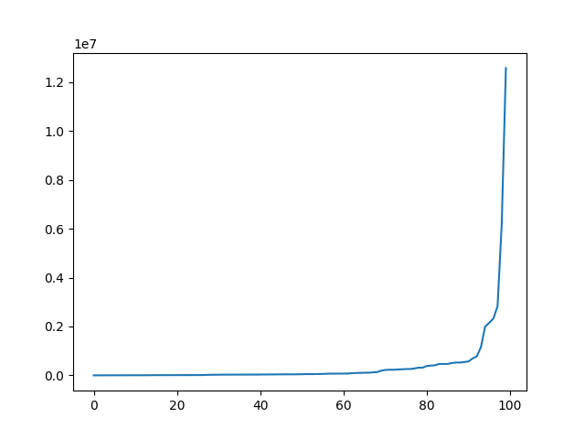

figure The money of gamblers

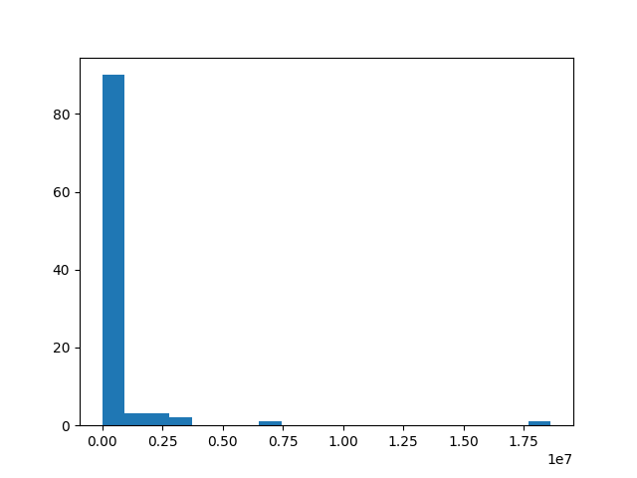

figure The distribution of gambling earn

For estimation of how the times of play affect loss rate

The loss rate in this play is 0.03

Try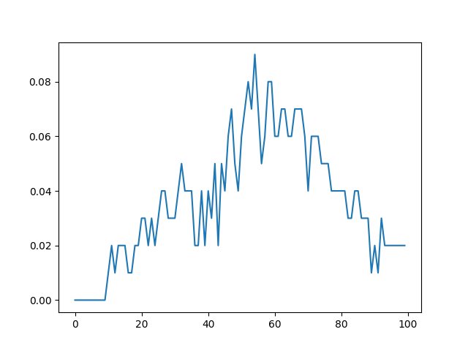

Try to use half Kelly to get the failure rate

The avg earn is 78560. The max earned is 586362

The failure rate is 0.02.

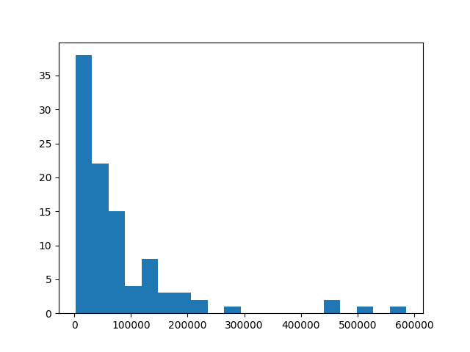

圖表 1The distribution earning of half Kelly

The failure rate pattern as below

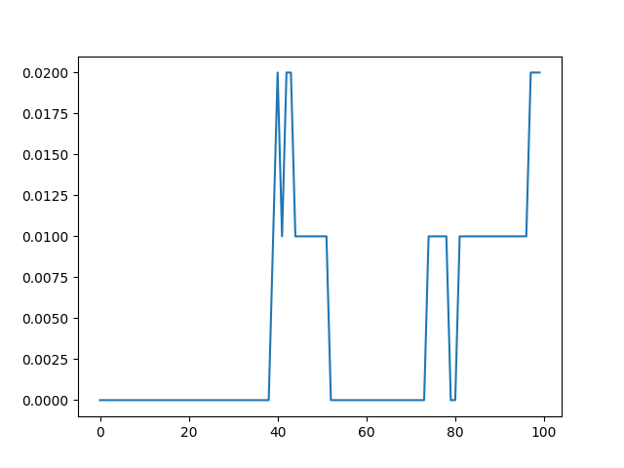

Try to increase the play times as double the match the expected earn of previous



